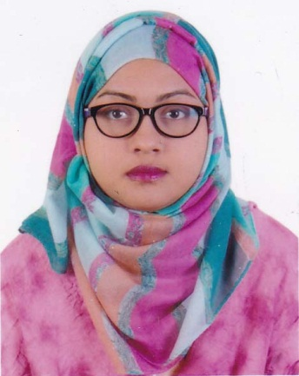**DILRUBA AKTER**

House # 140/3, Block-A, Road-01, ward-07.

Purbogram, Rupgonj, Narayangonj.

Cell: 01797-439934

**CAREER OBJECTIVE**: Challenging Career in a dynamic organization where there is an opportunity that provides an excellent job environment for career growth and practices a professional performance culture where the quality performance of talent and creativity is recognized and rewarded as well as to utilize my knowledge and experience for professional career development.

**ACADEMIC QUALIFICATION**

Year: 2012 **Master Of Business Administration (MBA)**

Institution : South East University

Result : 3.58

Subject : Finance

Year: 2009 **Bachelor Of Business Administration (BBA)**

Institution : Adamjee Cantonment College

Result : 3.24

Subject : Finance

University : National University

Year: 2005 **Higher Secondary Certificate (H.S.C)**

Institution : Shahid Bir Uttam Lt. Anwar Girl’s College

GPA : 4.30

Grade : A

Group : Commerce

Board : Dhaka

Year: 2003 **School Secondary Certificate (S.S.C)**

Institution : Balughat High School & College

GPA : 3.88

Grade : A –

Group : Commerce

Board : Dhaka

**EXPERIENCE** :Six years of teaching experience at different Colleges & English Medium School. Now working as a teacher of Oxford International School.

**COMPUTER COMPETENCY** : Excellent Computer literacy in basic & Computer Certificate Course (MS – Word, Excel, Access, power point, E-mail & Internet)

**LANGUAGE SKILLS** : Excellent Bengali &English communication

**PERMANENT ADDRESS** : Vill + P.O :Purbagram Bazar, P.S : Rupgonj,

Dist:Narayangonj.

**PERSONAL DETAILS** Husband’s Name : Md. JubayerRahman

Father’s name : KaziNurulAlam

Mother’s name : Nahida Islam

Date of Birth : 7th July, 1988

Nationality : Bangladeshi

Gender : Female

Marital Status : Married

Religion : Islam

Blood Group : B +

**REFERENCES** 1. Md. Jahidul Islam

Coordinator, Department of BBA

Adamjee Cantonment College

Cell : 01716 172747

2. Md. MashiurRahman

Barrister, Bangladesh Supreme Court

Cell : 01912 135304

I, the undersigned do hereby certify that this C.V correctly describes my qualification and myself. I understand that any willful misstatement described herein may disqualification or dismissal, if employed.

**SIGNATURE:**

Dilruba Akter

Date :21-02-2020